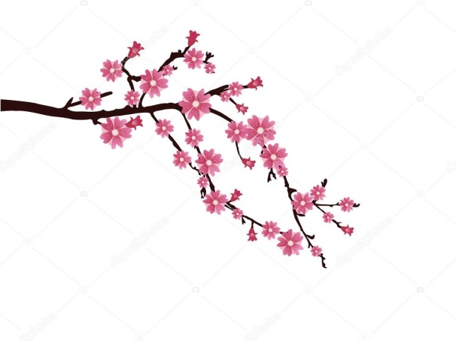
Spring 2018

ChÏsane MENU

Hamachi | Sashimi with sakura ponzu
KING CRAB | Sake | elderflower | spring salad
Daikon salad | wild ginger | cherry

TOM KA MiDKON
Razor clams | coconut | Thai basil
Thai style duck dumplings | green mango
Local veal tataki | mango | peanut | coridander

Local lamb
kogi | black beans | morels | Morels | mushrooms
aubergine | schezuan peppers
lamb nigari | salter roe

SAKURA TREE
Cherries | dark chocolate

